Họ và tên: Nguyễn Đình Việt Hoàng

MSSV: 522H0120

Lab 4:

Bài 1:

Bài 2:

Bài 3:

Bài 4:

Bài 5:

Bài 6:

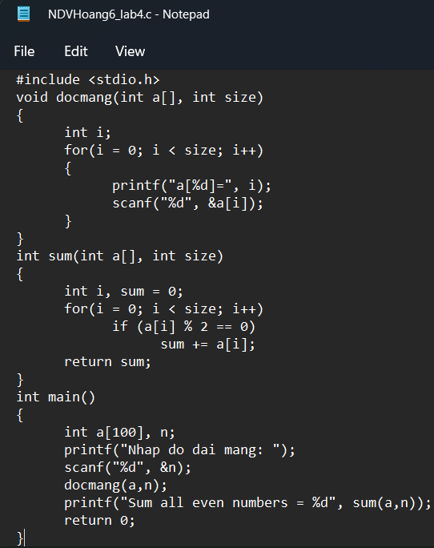

Bài 7:

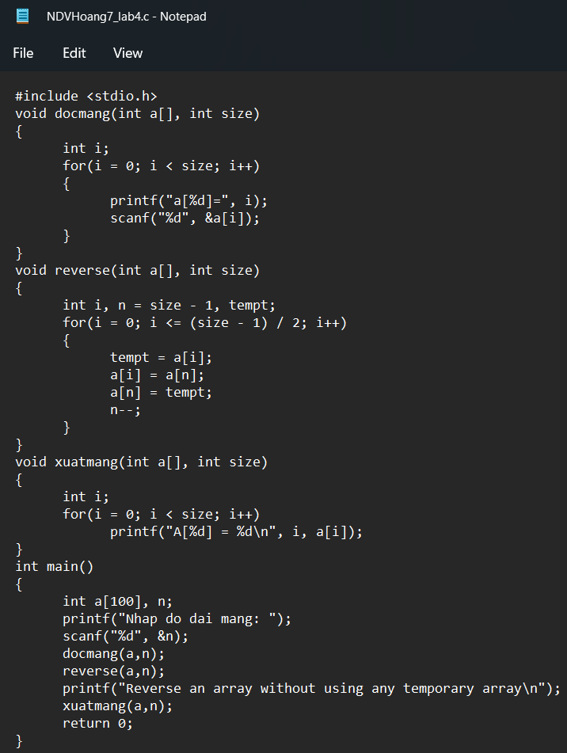

Bài 8:

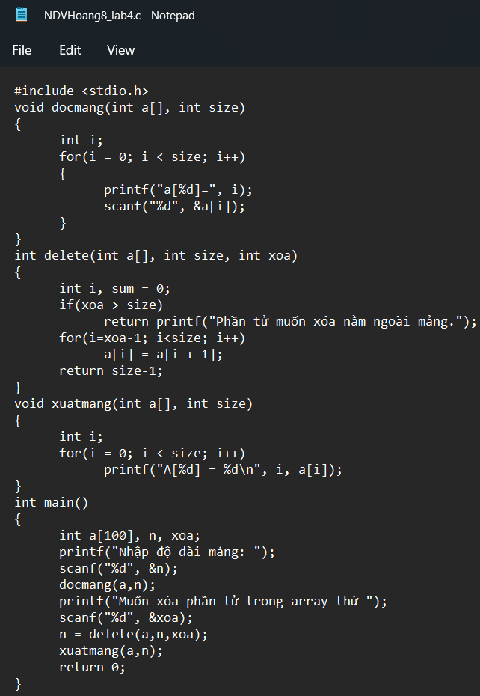

Bài 9:

Bài 10:

Bài 11:

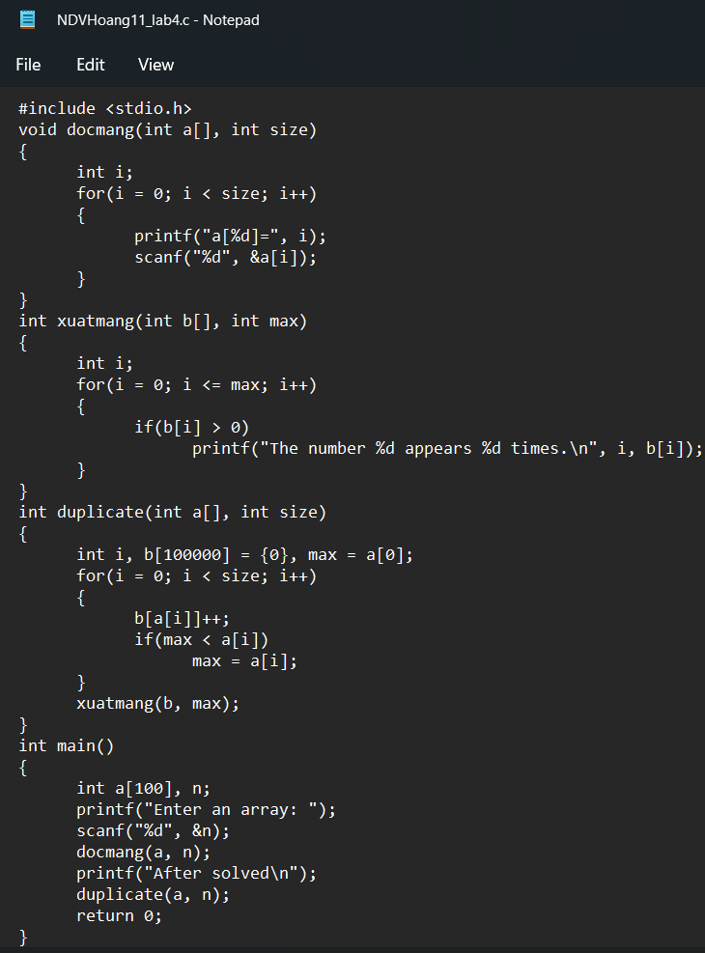

Bài 12:

Bài 16:

Bài 17:

Bài 18:

Bài 19:

Bài 20:

Bài 14:

Bài 15:

Bài 13:

